

**Asset Practice Questions: Mathematics**

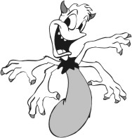1. Look at this monster.

How would you count the total number of hands on 15 such monsters?

A.15 + 4

B. 15 - 4

C. 4 + 15

D. 4 x 15

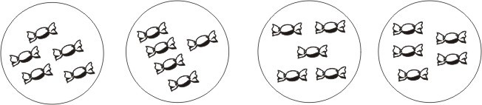2. Look at the picture below.

Which of the following facts does this picture show?

A. 18 + 2 = 20

B. 4 + 5 = 9

C. 4 + 4 + 4 + 4 = 16

D. 4 x 5 = 20

3. 5 ×



= 5

Which of these can come in  ?

A. 1

B. 2

C. 5

D. 0

4. What should be added to 4 × 5 to get 4 × 6?

A. 1

B. 4

C. 5

D. 6

5. What is 3 times 13?

A. 16

B. 39

C. 133

D. 313

6. How much MORE is 4 × 9 than 4 × 8?

A. 36

B. 32

C. 9

D. 4

7. A tailor has to put 5 buttons on a shirt. How many buttons will he need for 12 shirts?

A. 12 + 5

B. 12 × 5

C. 5 + 5 + 5 + 5 + 5

D. 12 × 12 × 12 × 12 × 12

8. Which of these is equal to 9?

A. 9 × 0

B. 1 × 9

C. 1 + 9

D. 9 - 1

9. As shown in the picture below, there are some loose beads and some beads in jars. Each jar contains

10 beads.

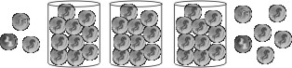

How many beads are there in all?

A. 12

B. 36

C. 39

D. 120

10. What number comes just BEFORE 5 tens?

A. 49

B. 40

C. 14

D. 4

11. 7 ones + 9 tens = A. 16

B. 27

C. 79

D. 97

12. What are the next two numbers in the pattern? 8, 13, 18 , 23, , A. 28 and 33

B. 33 and 43

C. 33 and 35

D. 38 and 43